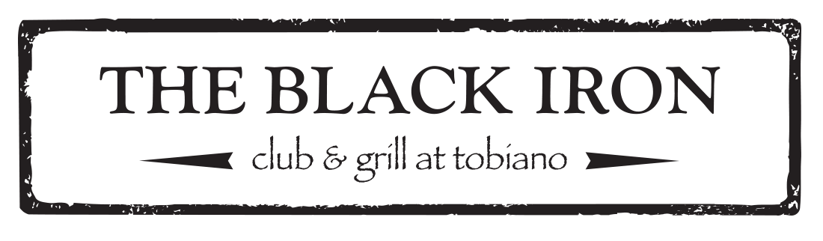

Bubbles

Henkell Mini - Germany

Sparkling Rosè

$9.50

Lamarca - Italy

Prosecco

$38

Piper Heidsieck - France

Brut

$100
White Wines
 |  |  | 6oz | 9oz | Bottle
Jackson Triggs | International | Sauvignon Blanc | 6 | 9 | 24
Red Rooster | BC | Chardonnay | 8 | 12 | 32
Monte Creek | Kamloops | Rosè | 8 | 12 | 32
Ruffino | Italy | Pinot Grigio | 8 | 12 | 32
Kim Crawford | New Zealand | Sauvignon Blanc | 9.5 | 14.25 | 38
Harpers Trail | Kamloops | Silver Mane - Riesling |  |  | 38
Privato | Kamloops | Gewurztraminer |  |  | 38
Privato | Kamloops | French Oak - Chardonnay |  |  | 52

Red Wines
 |  |  | 6oz | 9oz | Bottle
Jackson Triggs | International | Cabernet Sauvignon | 6 | 9 | 24
Red Rooster | BC | Cabernet Merlot | 8 | 12 | 32
Inniskillin | BC | Pinot Noir | 8.50 | 12.75 | 34
Robert Mondavi | USA | Bourbon Barrel - Cabernet Sauvignon | 8.50 | 12.75 | 34
Maggio | USA | Petite Sirah | 9.50 | 14.25 | 38
Ravenswood | USA | Lodi Old Vine Zinfandel |  |  | 45
Nk’ Mip | BC | Syrah |  |  | 49
Duckhorn | USA | Cabernet Sauvignon |  |  | 70

